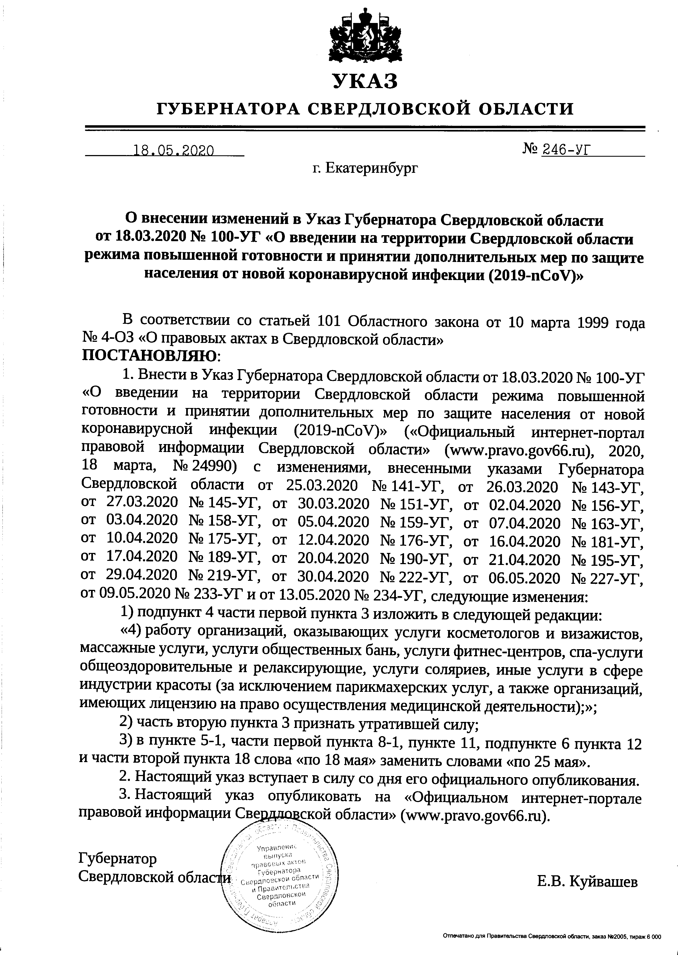
YKAS
IyBEPHATOPA CBEPAJTOBCKOTZ OEJTACTTT

18.05.2020

- ErarepzH6ypr
Ns
246-Vf

O sgeceHrrn rnMeHenufi s Yxa3 ly6epHaropa Cnep4rrroncroil o6nacrn
or 18.03.2020 Ns 100-yT <O nne4eHrrrr Ha reppnTopuu Cnep4toscxofi o6nacru

pexrrMa [oBblrrrenHofi roroBHocrrr rr trplrHflTttuAorroJlHrrreJlbHbD( Mep rro 3arrlr{Te
HaceJreHrrfl or nonofi KopoHaBrpycHofi uHQexquu (201g-ncov)>

B coorsercrBut4 co crarbefi 101 O6nacnroro 3aKoHa or L0 Mapra lggg ro4a

I{b 4-O3 <<O
npaaoBbrx
arff.x n Cuep4noscxofi
o6nacru>

TIOCTAHOBTIflIO:
(O 1. BHecru s Yxa: fy6epnaropa Caep4noncxofi o6lacra or 18.03.2020 Ns 100-yT
BBeAeHI,IH Ha reppl{Topl.ru Csep4noncxofi o6racru pexrMa nosrrueHHofi
roroBHocru t4 rrpvwrrut4 AononHureJrbHbrx Mep no 3aIr{HTe Hace/reHHfl or Hosofi
KopoHtlBl'Ipy$rofi zHQexqzn (2019-nCoV), (<OQuqualruufi LrHrepHer-ropraJr
nparoeofi unQoprvraqrua Ceep4roncxofi o6aacna> (www.pravo.gov66.ru), |OZO,
18 Mapra, No 24990) c I,I3MeHeHH.EMH, BHeceHHbrMH yxasa*, Iy6epuaropa
Crep4noncxofi o6nacru or 25.03.2020 Ns 141-yT, or 26.03.2020 Ns 1+3-yf,
or 27.03.2020 Ne L45-yT, or 30.03.2020 I\b 151-yT, or 02.04.2020 Ne LS6-yT,
or 03.04.2020 Ns 158-yT, or 05.04.2020 Ns 159-yT, or 07.04.2020 Ns 1G3-yT,
or L0.04.2020 Ns 175-yT, or 12.04.2020 Ne 176-yT, or L6.04.2020 Ne t B1-yT,
or L7.04.2020 Ne 189-yT, or 20.04.2020 Ne L90-yT, or 2L.04.2020 Ns 1-95-yT,
or 29.04.2020 Ne 219-yT, or 30.04.2020 Ne 222-yT, or 06.05.2020 Ns2ZZ-]rr,
or 09.05.2020 Na 233-yT u or 13.05.2020 Na 234-yT, cneAJrrorque r,BMeHeH:zlr:

- no4rrynnr 4 qacna nepeofi ryHKra 3 zgrorc,rrb B cJreAJrrouqefi pe4arc4na:
<4) pa6ory opraHrcal{nil, oxa:rrBarorrlux ycnyr[ KocMero/roroB u Bu3uKtncroB,
MaccDKHbIe ycnyrH, ! cttytu o 6IqecrneHHblx 6 anr, yuryru QurHec-qeHrpoB, cna-ycnyrg
o6qeos4opoBrlTenbHble H penaKczp)norr{He, ycnyr[ conspzeB, ilHbre y.ryry e-cQlpe
HI{AycrPHH Kpacorbt (sa zcxlrcqeHueM rapuKMtxepcKr{x ycnyr, a raKxe opraunsaqufi,
HMeIoqlD( nI{I{eH3HIo Ha flpaBo ocyrqecrBrreHnfl MeAur{raHcxofi AeflTerrbHocru);>;
- uacrr Bropyro ryHrffa 3 npurHarb yrparasurefi crny;
- n nynrre 5-1-, qacru nepaofi nyHKra B-1, nyHxre 11, roArrynKre 6 nynxra 12
u qacrH ntopofi flyHlma L8 cnosa <<no L8 Mafl>) 3aMeHr,rrb cJroBalMH <no 25 Mafl>.
- Hacromr{uiayxaz BcrJmaer B cuJry co AHfl ero oQuqu;urbHoro ony6nuxoBaHgfl.
- Hacrosu{ufi yKa3 ony6auxonarr Ha <OQzquaabHoM r{HrepHer-[oprrue

nparosofi
r,luQopnrarl uu
C
fi
o6nacru> (www.pravo.gov66.ru).

fy6epnarop
Cuep4noncrofi | E.B. KyfiBarrreB
OmdaEHo | trx npa6rrd@ C4pArorei oEtaffi, s(B N02OO5, ffpd 6 OOO

